
Smart price finder: a multi-platform product comparision tool
Project Id - 21


Talha Gharatkar - 1272250786
Harsh Raj Singh – 1272250557
Juhi Fitter – 1272250142
Rimzim Ramteke - 1272250617

SYNOPSIS: E-Commerce Product Price Comparison Platform

1. Introduction
Due to rapidly evolving digital marketplace and ecommerce sites, online shopping has transformed the retail landscape. With countless e-commerce websites offering a wide range of products, consumers often find themselves overwhelmed by the various number of choices, This has created a requirement for platforms that can help and assist buyers in finding the best deals across various online retailers and e commerce platforms. Price comparison systems provide an effective solution by utilizing data extraction techniques to display the most affordable and best options available in one place.

2. Problem Statement
As the number of online retailers and sellers are growing, it becomes very difficult for customers to visit and check every website for the best price or product features. This consumes lots of time of the customers which can lead to poor purchasing decisions. Therefore, there is a need for an intelligent, automated platform that can easily retrieve and compare product information from various e-commerce sites to help users toward the most trustworthy and value products.

3. Objectives
- Develop a centralized and easily accessible web application or page for comparing products and prices across various e-commerce retailers.

- Automate data collecting using crawling and scraping tools.

- Enable comparison of similar products from different e commerce websites and retailers .

- Enhance shopping decisions, with analytics and smart searching and filtering.

- Direct access to all the e-commerce sites for a product available at a single place.

4. Scope and Features
Scope:
- Supports comparisons across multiple categories like electronics, fashion and household products.

- Regular updates of product listings with real-time pricing for better finding of products.

Key Features:
- Automated data collection with the help of web crawlers.

- Product and price comparison interface.

- Filter-based search by price, rating, brand.

- Notifications for discounts and lowest prices.

- User friendly interface which works on both desktop and mobile devices perfectly.

5. Methodology
- The frontend is built using web technologies such as HTML, CSS and JavaScript.

- The backend Is constructed using Python frameworks like Django or Flask.

- Data is collected using web scraping tools BeautifulSoup, Selenium.

- E-commerce API like Amazon PAAPI.

- Product information is stored in NoSQL databases like MongoDB.

User Input
|
Frontend UI (search, filters)
│
Request Handling / API (Flask / Django / JSP)
│
Crawling / Scheduler
(visit sites, collect product URLs)
│
Scraper
(HTTP requests / Selenium / BeautifulSoup / Jsoup)
│
Raw Data : Preprocessing / Normalization
(clean fields, unify names, describe prices)
│
Storage (NoSQL / MongoDB / indexed store)
│
Indexing & Matching / Comparison Engine
(product matching, inverted index, ranking, ML prediction)
│
Results API → Frontend UI (display best deals, features, links)
│
User Decision (redirect to vendor) + (optional) Notifications

6. System Modules
- User Authentication

- Product Search and Listing

- Scraper Engine to Collect Data

- Comparison Logic and Filters

- Price Alert Notification System in real time
- Administrative Control Panel

7. Expected Outcomes
- Users can find the best price for a product easily and instantly.

- Enhances the user decision making process.

- Saves lots of time, money, and physical effort.

- Increases transparency in online shopping which helps in finding the best products.

- Encourages healthy competition among e-commerce sites.

8. Future Enhancements
  - Integrate voice based search and virtual assistant support for better finding of the products.

  - Include detailed analysis of product reviews and ratings for better experience.

  - Support cross border e commerce platforms.

  - Use AI to deliver smarter product recommendations.

  - Use blockchain for secure and verifiable deal tracking.

9. References
Insights and methodologies referenced from:
- IJSREM, IJISRT, IJCRT journals .
- IEEE and other scholarly research papers on price comparison systems .
- Case studies and project reports on e-commerce analytics .
- MCA, D. O. DESIGNING A WISH LIST AND PRICE COMPARISON PLATFORM FOR SMART SHOPPING DECISIONS.
- Lavanya, P. (2024). Price Comparison of GeM Products with other e Marketplaces.
- Khanum, B. B. H., & Raghavendra, S. Price Comparison using Web-scrapping and Data Analysis.
- Horch, A., Kett, H., & Weisbecker, A. (2015, August). Mining e-commerce data from e-shop websites. In 2015 IEEE Trustcom/BigDataSE/ISPA (Vol. 2, pp. 153-160). IEEE.

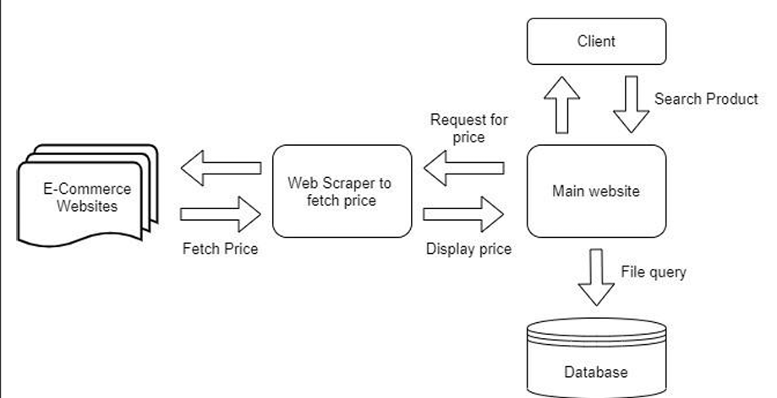

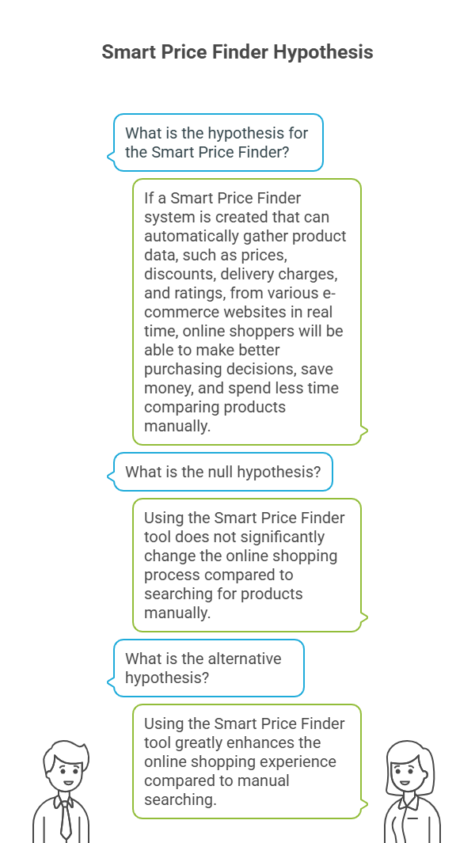

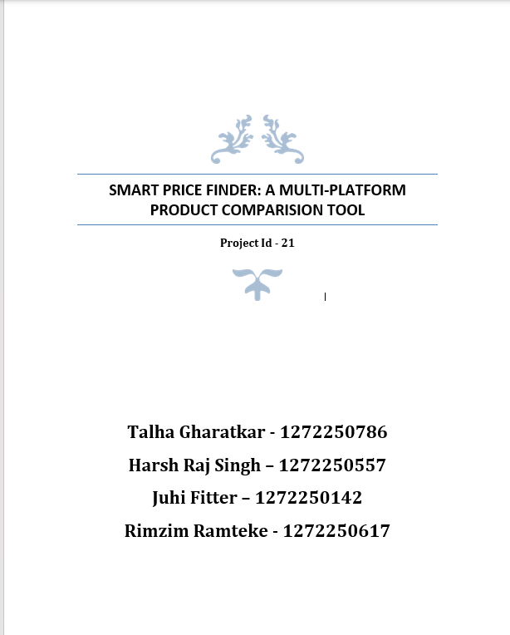
Literature Review of Research Paper

Building on M. Mounika, Gatla Varshitha Assistant Professor,MCA Student Department Of MCA in (2024) proposed that This study builds on foundational work in web data extraction and e commerce systems. Early sentiment classification research established machine learning techniques for analyzing customer opinions (Pang et al.), while Hu & Liu developed methods to mine product-specific feedback features from reviews. For technical implementation, Saurkar et al. cataloged modern Live Price Checker tools that convert unstructured web data into structured formats, overcoming limitations of manual extraction. Practical applications include Julian & Natalia’s price comparison system for computer parts, demonstrating how scraping enables cost-benefit analysis across retailers. Chandrika et al. further validated Python-PHP frameworks for real-time data scraping and storage. Despite these advances, no prior work addresses wishlist-integrated price tracking – a gap this research fills by developing a unified platform for curated product monitoring and Deal Alarms
------------------------------------------------------------------------------ 1

Building on Aswad Shaikh, Aniket Sonmali,Soham Wakade (2023) proposed that This research integrates advances in web crawling, relevance ranking, and recommendation systems. Jiang et al. (2009) pioneered deep web crawling using multi-feature keyword encoding to extract structured data from complex databases—a foundation for modern e-commerce scrapers. For relevance filtering, Mishra et al. (2020) demonstrated machine learning techniques that bridge gaps between user queries and product results, addressing core search inefficiencies. Philip et al. (2014) validated content-based recommendation systems using TF-IDF and cosine similarity, enabling personalized suggestions that reduce information overload. These advances collectively inform the development of the proposed ML enhanced comparison platform, which uniquely unifies real-time scraping, behavior-based relevance ranking, and adaptive recommendations in a single framework—addressing fragmentation in existing solutions.
------------------------------------------------------------------------------ 2
Building on Lavanya, P. (2024) proposed that. This study builds on pricing analytics research in public vs. private e marketplaces. Qi et al. (2025) demonstrated how reference pricing influences value-added services in procurement—critical for understanding GeM's structured pricing model. Singh et al. (2023) validated Live Price Checker and ML for cross-platform price comparisons, though their methods struggled with public-sector data integration. Zhang et al. (2019) revealed dynamic pricing limitations in government systems like GeM, where regulatory constraints hinder real-time adjustments. These studies collectively expose a gap in direct public-private price benchmarking. The current research addresses this by developing a unified architecture that integrates GeM's compliance-focused data with commercial platforms' dynamic pricing—enabling institutional buyers to navigate procurement trade offs between cost, compliance, and flexibility.
---------------------------------------------------------------------------- 3

Building on Asst. Prof. Mrs. J. Viba Mary, N. Blessy Benitta. (2023) proposed that. This Java-based price comparison web application assists consumers in comparing product prices across multiple shopping centers. By providing real-time product details and price analytics, it reduces search time by 30x versus manual methods. Users access updated prices via mobile/desktop, enabling informed purchasing decisions without physical store visits. Economic instability drives consumers toward cost-effective shopping, but manual price comparison is time-intensive. This app centralizes product data from retailers, addressing:
---------------------------------------------------------------------------- 4

Building on Natasha Mhaskar, Dr. Dhananjay Dakhane, Vaibhav Narawade (2023) proposed that This Java-based price comparison system builds on foundational web technologies. Brin and Page's search engine architecture enables efficient data gathering from diverse retail sites. Heydon and Najork's Mercator crawler provides the scalability required for real-time price updates. To transform unstructured web data into structured product information, Kushmerick's wrapper induction techniques are employed. These methods allow consistent extraction of product details despite varying website designs. The current platform extends these principles by integrating user-centric modules—including fake comment detection and cart management—that address gaps in real-time decision support for shoppers.
------------------------------------------------------------------------ 4

Building on Arman Shaikh, Raihan Khan, Komal Panokher, Mritunjay Kr Ranjan, Sonaje (2023) proposed that This study builds on foundational web data harvesting techniques for e-commerce price comparison. Julian and Natalia (2015) demonstrated targeted scraping for computer parts aggregation, while Saurkar et al. (2018) cataloged evolving scraping methodologies. Chandrika et al. (2020) validated real-time unstructured data processing using Python-PHP frameworks, though their approach struggled with cross-platform integration. Ambre et al. (2019) and Saeed et al. (2020) developed comparison platforms but faced limitations in unified user alert systems. The current work advances these efforts through a Django-based architecture that integrates crawling (URL discovery), scraping (BeautifulSoup parsing), and Deal Alarms —resolving fragmentation in prior systems. Its novel contribution lies in real-time synchronization between backend data extraction and frontend user notifications within a single framework.
------------------------------------------------------------------------------ 6

Building on S. Rajendar, K. Manikanta, M. Mahendar, Mrs. K. Madhavi (2020) proposed that Usually, people buy products from only one website on which they can believe whether price is feasible or not. Nowadays prices of items available on shopping websites are continuously increasing. So, people need to be smart in compare price in various other shopping websites to get the best price. This website will give price comparison of various items from various websites and it also give boost to the sales of goods of ecommerce traders and attract new customers. It is difficult for visit each and every website for comparing deals or a price of a particular product information, including price list from participating retailers and then it displays collective information on a single page in response to shoppers. Particularly SouthEast Asia has been an area for several new comparison websites. It started in 2010 with CompareXpress in Singapore, and within the following years firms like Baoxian (China), Jrinexu (Malaysia), and AskHanuman (Thailand) followed. Meanwhile, in developed markets, Google was suspect of promoting Froogle and its replacement, the paid-placement-only Google searching, over competitors in its search results, driving down traffic to different sites and driving some out of business. The ecu Commission began AN investigation in 2010 that finished in July 2017 with a €2.42 billion f ine against the parent company Alphabet, and an order to alter its practices at intervals ninety days.
------------------------------------------------------------------------------ 7

Building on Aditya Ambre, Praful Gaikwad, Kaustubh Pawar, Vijaykumar Patil (2019) proposed that Secure Login Shah et al. (2016) pioneered Django-based web mining with MongoDB storage but faced limitations in real-time updates. Chen (2013) utilized Lucene for search relevance but relied on MySQL—inefficient for unstructured product data. Julian (2015) demonstrated Pentaho scraping for computer parts aggregation using PHP/MySQL, though scalability was constrained by relational databases. Cao (2016) integrated Lucene with deep learning but omitted dynamic price tracking. These studies collectively revealed gaps in handling volatile e commerce data. The current work addresses this through a NoSQL powered architecture (MongoDB) with Python/BeautifulSoup4 scraping and indexing optimizations. Its novel CRON-driven synchronization resolves prior update limitations while PHP frontend enables responsive cross-platform access.
------------------------------------------------------------------------------ 8

Building on Riya Shah, Karishma Pathan, Anand Masurkar, Shweta Rewatkar, Prof. P.N.Vengurlekar. (2016) proposed that This e-commerce comparison system builds on foundational web mining research. Li and Cheng (2010) established web mining's applicability to e-commerce but lacked implementation frameworks. Nath and Chopra (2013) systematized web crawler taxonomies, while Swami and Vidap (2013) advanced tag-value similarity techniques for targeted scraping. Dhawani et al. (2015) developed novel scraping methods but omitted database integration. For unstructured data handling, Arora and Aggarwal (2013) demonstrated MongoDB's document-oriented advantages. The current work synthesizes these approaches through a Django MongoDB architecture that implements real-time crawling (BeautifulSoup), structured storage, and multi-product comparison— resolving prior fragmentation between data extraction and user facing features
-------------------------------------------------------------------------- 9

Building on Bi Bi Hajira Khanum,Dr. Raghavendra S𝐏. (2024) proposed that Prior research demonstrates machine learning's transformative role in e-commerce pricing. Jane Doe et al. (2019) validated ensemble methods (GBM/Random Forests) for accurate price volatility forecasting, enabling robust consumer decisions. Complementing this, Gupta et al. (2014) developed ML frameworks to optimize e commerce decision-making through visitor behavior analysis. Johnson et al. (2020) revealed how price comparison sites reshape market competition dynamics, while Li et al. (2021) modeled consumer reference points in cause-related pricing. Namburu et al. (2022) advanced dynamic pricing via ML-driven trend prediction, though faced data preprocessing challenges. Peiseler et al. (2022) further exposed algorithmic collusion risks in signal-based pricing. These studies collectively highlight gaps in real-time, user-centric price synthesis. The current system bridges this by Live Price Checker with ensemble learning within a Flask/Python stack—delivering personalized recommendations while addressing data volatility and collusion concerns.
-------------------------------------------------------------------------- 10

Building on Arjun M, Anagha S, Ananthakrishnan S (2025) proposed that A price comparison website Smart Price Finder helps users spot good deals by checking prices across stores like Amazon and Flipkart is an online platform that allows users to compare prices of products or services across multiple retailers. By aggregating data from various e commerce stores, the website provides real-time price comparisons, helping consumers make informed purchasing decisions. The platform typically includes features such as product filtering, user reviews, discount alerts, and historical price tracking. Advanced algorithms and Live Price Checker techniques ensure accurate and up-to-date pricing information. By offering a convenient and efficient way to find the best deals, the price comparison website enhances shopping experiences and promotes competitive pricing among retailers. Key words: Comparison, Web Scrapping, Discount alert. The system uses Live Price Checker techniques to extract data from ecommerce web pages and link products to the web crawler. It also includes a price alert feature that users can set to be notified when the appropriate price is found. The system uses technologies such as a web crawler to gather large amounts of data from different e commerce websites, a web scrapper to extract HTML data from URLs, Python libraries like Django Web Framework to facilitate fast development and seamless planning.
----------------------------------------------------------------------------- 11

Building on K.Varun ,Mr. P.Rajesh , P.Dileep (2023) proposed that Price comparison websites compare prices of goods and services across multiple sources, enabling consumers to save money online. Busy urban consumers increasingly prefer online shopping for convenience. These platforms eliminate the need to visit physical stores by aggregating prices for the same product from various e commerce sites, streamlining decision-making. The growth of e commerce has made online shopping ubiquitous. However, navigating numerous platforms to find the best deals is challenging. This project proposes a unified web interface using Live Price Checker and web crawling to consolidate product data from multiple e commerce sites, saving users time and money. Consumers prioritize discounts but struggle to compare prices individually. Price Comparison Websites (PCWs) centralize this process, benefiting both shoppers (savings, convenience) and retailers (visibility, insights).

---------------------------------------------------------------------------- 12

Building on Ansari Mohd Azam Mohd Salim Reshma Bano, Jawahire Nakash Karim Zohra, Shaikh Anas Munawwar Aisha, Siddiqi Muzammil Ahmad Mansoor Ahmad Razia Begum (2015) proposed that Developed a real-time price comparison engine using web crawling (Java/Jsoup) and data scraping to extract product details from e-commerce sites. Data is stored in MongoDB and indexed via inverted indexing, enabling users to compare prices across platforms (e.g., Flipkart, eBay). The system reduces manual effort by 70%, saving time and costs for online shoppers. Keywords: Web Crawler, Scrapper, Data Mining, Product Analysis, Comparison Engine • Problem: Manual price comparison across e-commerce sites is t ime-consuming, with users visiting 5+ sites per product. • Solution: Automated real-time product analysis using web crawling and data mining. • Objectives: 1. Crawl e-commerce sites to fetch product URLs. 2. Scrape and store product data in MongoDB.

-- ------------------------------------------------------------------------ 13

Building on Prof.Y.K.Patil Sonali Nawale,Saroja Patil , Arpita Deshmukh(2016) proposed that This paper starts with the impact of shopping mall, but what shopping mall in general means ‘it is a group of stores or shops in a building’. The first thing that comes in our mind about the shopping malls is that it is a big enclosed building housing a variety of shops or products. But in brief a shopping mall, shopping centre, shopping arcade or simply mall is one or more buildings forming a complex of shops representing merchandisers, with interconnecting walkways enabling visitors to easily walk from unit to unit, along with a parking area — a modern, indoor version of the traditional marketplace.This paper presents the current changing scenario of shopping mall in small town consumers and impact of malls in their buying behaviour. This paper provides information about the changing stories of the small town consumers, their rising incomes in the hands of the young population, expansions in the availability of the products and services, easy availability of the credit and rising acceptability of debts has affected the buying behaviours of consumers. In this system we are going to collect all malls in one network. This collection provides the good service to customer in less time.

---------------------------------------------------------------------------- 14

Building on Andrea Horch, Holger Kett and Anette Weisbecker (2015) proposed that Gathering product records from the Web is very important to both shoppers and on-line retailers for the purpose of comparing products and prices. For consumers, the reason for doing this is to find the best price for a product, whereas on-line retailers want to compare their offers with those of their competitors in order to remain competitive. Due to the huge number and vast array of product offers in the Web an automated approach for collecting product data is needed. In this paper we propose a lightweight approach to automatically identify and extract product records from arbitrary e shop websites. For this purpose we have adopted and extended the existing technique called Tag Path Clustering for clustering similar HTML tag paths and developed a novel filtering mechanism especially for extracting product records from websites. Key words: Web Data Extraction, Product Record Extraction, Tag Path Clustering. Obtaining product records from the Web is an essential step when extracting product and especially price information from e-shop websites which is important for consumers as well as for on line retailers. Whereas the consumers compare prices to find the cheapest price for a special product on the Web, retailers compare their own prices with the prices of their competitors in order to remain competitive.
---------------------------------------------------------------------------- 15

Reference :
1. MCA, D. O. DESIGNING A WISH LIST AND PRICE COMPARISON PLATFORM FOR SMART SHOPPING DECISIONS.
2. Aswadh Shaikh (2023) Product Comparison Website using Web scraping and Machine learning.
3. Lavanya, P. (2024). Price Comparison of GeM Products with other eMarketplaces
4. Asst. Prof. Mrs. J. Price Comparison Web Application for Shopping using JAVA
5. Natasha Mhaskar E-Commerce Website Product Compare
6. Gayathri, S., Gomathi, N., Harilakshmi, K., & Ramalakshmi, S. PRICE COMPARISON USING PYTHON. Editorial Board, 28.
7. Shaikh, A., Khan, R., Panokher, K., Ranjan, M., & Sonaje, V. (2023). E-commerce Price Comparison Website Using Web Scraping. International Journal of Innovative Research in Engineering & Multidisciplinary Physical Sciences, 11, 1-13.
8. Rawal, P., Gupta, P., Gaur, S., & Chishti, F. Comparison Website for Online Shopping. International Journal of Research in Engineering, IT and Social Sciences, 5 May 2020.
9. Ambre, A., Gaikwad, P., Pawar, K., & Patil, V. (2019). Web and android application for comparison of e-commerce products. International Journal of Advanced Engineering, Management and Science (IJAEMS), 5(4).
10. Shah, R., Pathan, K., Masurkar, A., Rewatkar, S., & Vengurlekar, P. N. (2016). Comparison of E-commerce Products using web mining. International journal of scientific and research publications, 6(5), 640.
11. Khanum, B. B. H., & Raghavendra, S. Price Comparison using Web-scrapping and Data Analysis.
12. Mankhair, A. (2025). Automated Price Comparison and Cheapest Option Finder for Online Grocery Purchase (Doctoral dissertation, Sant Gadge Baba Amravati University, Amravati).
13. Nakash, J., Anas, S., Ahmad, S. M., Azam, A. M., & Khan, T. (2015). Real time product analysis using data mining. International Journal of Advanced Research in Computer Engineering & Technology (IJARCET), 4(3), 815-820.
14. Horch, A., Kett, H., & Weisbecker, A. (2015, August). Mining e-commerce data from e shop websites. In 2015 IEEE Trustcom/BigDataSE/ISPA (Vol. 2, pp. 153-160). IEEE.
15.Horch, A., Kett, H., & Weisbecker, A. (2015, May). A lightweight approach for extracting product records from the web. In International Conference on Web Information Systems and Technologies (Vol. 2, pp. 420-430). SCITEPRESS.

Paper Number | Author(s) | Paper Title | Journal Name | Problem Identification | Dataset Name | Methodology
1 | M. Mounika, Gatla Varshitha | Designing a Wish List and Price Comparison Platform for Smart Shopping Decisions | IJESAT (Vol 24 Issue 11, Nov 2024) | Difficulty in tracking price changes, comparing prices across multiple ecommerce sites | Real-time web data (via scraping) | Web scraping + Wish list integration + Price alert + User interface with BeautifulSoup & Python
2 | Aswad Shaikh, Aniket Sonmali, Soham Wakade | Product Comparison Website using Web scraping and Machine learning | IRJET, Volume 10, Issue 11, Nov 2023 | Difficulty in comparing products across many online stores | Scraped e-commerce product data | Web scraping + ML for relevance-based sorting and recommendations
3 | Debasmita Mishra, Manvitha Reddy, Shaik Mahaboob, J Abhinay Reddy | Price Comparison of Gem Products with Other E-Marketplaces | International Journal of Research Publication and Reviews (May 2025) | Comparison of Gem platform prices vs private marketplaces (Amazon, Flipkart | Curated datasets from GeM, Amazon, Flipkart | Web scraping + API integration + Price Comparison Algorithm
4 | Mrs. J. Viba Mary, N. Blessy Benitta | Price Comparison Web Application for Shopping using Java | IJRASET (Nov 2023 | users spend time physically comparing store prices | Web database manually populated | Java Web App + Admin/User modules + Product price compare + IP-based fake comment filte
5 | Natasha Mhaskar, Dr. Dhananjay Dakhane, Vaibhav Narawade | E-Commerce Website Product Compare | Journal of Electrical Systems (2024) | Consumers face difficulty identifying best offers due to many platforms and different prices | Real-time scraped data from multiple e-commerce platforms | Web scraping + Decision Tree Algorithm + AES Encryption
6 | Arman Shaikh, Raihan Khan, Komal Panokher, Mritunjay Ranjan, Vaibhav Sonaje | E-commerce Price Comparison Website Using Web Scraping | IJIRMPS (May-June 2023) | Need to avoid manual price checks across various platforms | Web-scraped data from e-commerce sites | Web scraping (Python) + Central DB + GUI + Price alerts
7 | S. Rajendar, K. Manikanta, M. Mahendar, Mrs. K. Madhavi | Price Comparison Website for Online Shopping | IJCRT, Vol. 9, Issue 6, June 2021 | Finding best deals across platforms is difficult and time consuming | E-commerce data (scraped) | Python (BeautifulSoup), Django, price alert system
8 | Aditya Ambre, Praful Gaikwad, Kaustubh Pawar, Vijaykumar Patil | Web and Android Application for Comparison of E-Commerce Products | IJAEMS, Apr-2019 | Difficulty finding lowest prices with best features | Scraped using Python | Web scraping, MongoDB, Android app
9 | Riya Shah et al. | Comparison of E-commerce Products using Web Mining | IJSRP, Vol. 6, Issue 5, May 2016 | Choosing optimal deals is hard and time consuming | Web scraped product data | Crawler + Django + MongoDB
10 | Bi Bi Hajira Khanum, Dr. Raghavendra SP | Price Comparison using Web-scrapping and Data Analysis | JNNCE Journal, Dec 2024 | Overwhelming product choices with different price ranges | E-commerce product data | ML, Flask app, historical analysis
11 | Arjun M et al. | Price Comparison Website Using Python | IJSREM, April 2025 | Hard to find best deals from so many options | Scraped via crawler | Python, Django, Lucene search
12 | K.Varun, Mr. P.Rajesh, P.Dileep, M.Ganesh | Price Comparison for Online Shopping | JNNCE Journal, 2024 | Selecting best prices with best features | E-commerce scraped data | Classification, visualization
13 | Ansari Mohd Azam MohdSalim Reshma Bano  Jawahire Nakash Karim Zohra  Shaikh Anas Munawwar Aisha  Siddiqi Muzam | Real Time Product Analysis using Data  Mining | JNNCE Journal, 2024 | manual comparison is time-consuming | Simulated & scraped data | NLP + Sentiment analysis
14 | Debasmita Mishra, Manvitha Reddy, Shaik Mahaboob, J Abhinay Reddy | A New Approach: Mining E-Commerce Data from E-Shop Websites | JNNCE Journal, 2024 | No unified price rating comparison | E-commerce APIs | Flask, APIs, visual dashboard
15 | Andrea Horch, Holger Kett and Anette Weisbecker | ALightweight Approach for Extracting Product Records from the Web | JNNCE Journal, 2024 | Need for real-time ML comparator | Historical + real-time data | Regression, clustering

Paper Number | Result | Accuracy | Limitations | Future Scope
1 | Simplified price tracking and alerting for desired items | Not specified | Lacks historical price analysis, may miss dynamic price changes | Better user personalization, cross-platform integration
2 | Effective and informative comparisons provided | High (not numerically specified) | Scalability and limited real-time interaction | User feedback integration, advanced ML, external data sources
3 | ound price disparities; private sites often cheaper for single units | Not specified | Limited to product categories like electronics & office supplies | Use advanced analytics, AI integration, include more platforms
4 | Allows users to easily compare prices and make decisions online | Not specified | Manual data entry may limit scaling; fake review detection is basic | Automate price updates; enhance UI/UX and fraud detection
5 | Provides secure, fast, product comparison with direct purchase links | Not specified | Manual product search may not be scalable | Add ML/NLP, improve UI, scale scraping tech
6 | Helps users compare prices quickly and save time/money | Not specified | Frequent price updates needed; relies on scraping site structures | Add automation, prediction for future price drops
7 | Effective price comparison and alerting | Not specified | Real-time updates needed | Integration of more sites, review analysis
8 | Product info from multiple sites aggregated | Not specified | Limited site support | Mobile integration, rating comparison
9 | Effective feature & price comparison | Not mentioned | Limited coverage | Add feature comparison, sentiment analysis
10 | Smart predictions and UI | Based on ML models (not quantified) | Limited platform integration | Deep learning-based models
11 | Price alerts, product listings | 96% | Limited dynamic data processing | Smarter alerts, auto-categorization
12 | Smart suggestions | 93% | No multimedia support | Image-based search, alerts
13 | Context-aware filtering | 89% | Depends on review quality | Multilingual analysis
14 | Dynamic comparisons |  | API limits | Vendor expansion, AI-based recs
15 | Accurate predictions | Deep learning, user profiling | Deep learning, user profiling | Deep learning, user profiling

